Chinese Ideas in the West Excerpts
Prepared by Professor Derk Bodde
China: A Teaching Workbook, Asia for Educators, Columbia University
Directions: Read and annotate below. Summarize or paraphrase each paragraph in one sentence on the margins.

Origins of the Civil Service
Today civil service is an accepted institution in all modern democracies. In the year 1941, for example, nearly 2,500,000 men and women took examinations for positions in the United States government.
So fundamental is the principle of choosing public servants on the basis of fitness that one might almost suppose it had been a cornerstone of our national thinking ever since our nation's beginnings. Yet, though few people stop to consider it, the fact is that this matter of efficiency in government is a relatively new idea in America. The first hundred years of our nation's history were racked with scandalous corruption as a result of the notorious spoils system. Not until 1883, two years after a president of the United States had been assassinated by a disgruntled office seeker, did the public wake up and demand a system of civil service examinations that would ensure the selection of most government employees on the basis of merit rather than party loyalty.
The civil service idea did not originate in our country…nor in Europe... The first county to install the merit system was China. In the year 165 B.C.E., China inaugurated what later became a widespread system of competitive government examinations. And during the greater part of the time from that early date until 1905, shortly before the Empire passed out of existence, the majority of Chinese applicants for public office had to prove their ability by passing one of these tests.
China and the Age of Enlightenment
As time wore on, various Chinese inventions such as printing, gunpowder, and the mariner's compass gradually found their way to Europe, also via the Arabs, who for centuries were the leading travelers and traders between East and West. Prior to the seventeenth century, however, the purely intellectual influence of China remained slight, perhaps because it was only then that Europeans themselves began to travel to the Far East in significant numbers.
The new era of Chinese-European contacts started in the year 1601, when the famous Italian Jesuit, Matteo Ricci (1552-1610), arrived in the Chinese capital, Peking, and established there a Catholic mission. For the next two centuries the Jesuits, as well as members of other Catholic orders, remained in close touch with the Court of Peking. By 1700 they were said to have converted approximately 250,000 Chinese to Christianity. Because these Europeans were highly educated men, they gained the respect of the Chinese, who have always placed a premium on scholarship. Many, indeed, were given important positions in the Chinese government. The Board of Astronomy, for example, was placed under their charge and remained a Christian stronghold until 1838.
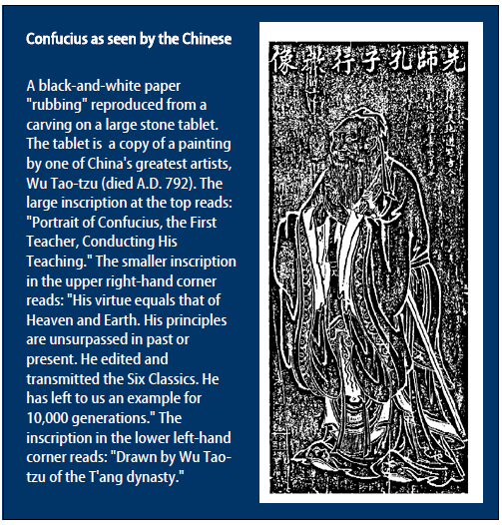
Fascinated by the ancient and impressive civilization in which they found themselves, these Europeans wrote home detailed accounts of what they saw. Their letters provided material for a long series of books on China, written usually in French or Latin and published in Paris, the European center of Jesuit activities. Among them were such works as Confucius, the Philosopher of the Chinese (1687); the Description of China (1735), in four volumes; the long series of Edifying and Curious Letters, in 34 volumes (1702-76); the General History of China, in 13 volumes (1777-85); and the lengthy Memoirs on the History, Sciences, Arts, etc., of the Chinese, in 16 volumes (1776-1814).
These writings gave Europeans a far more detailed and accurate picture of China than they had ever had before. They generated a tremendous enthusiasm for China and things Chinese — an enthusiasm that reached its peak in the early years of the second half of the eighteenth century. Materially, this enthusiasm powerfully influenced such fields as painting, architecture, landscape gardening, furniture, and the newly developed manufactures of porcelain and lacquerware — the well-known and charming chinoiseries of the eighteenth century. It also left a strong imprint on literature and on the thinking of some of the most famous intellectual figures of the period.
The timing of this impact from China was of particular importance. It reached Europe during a period of tremendous political and intellectual ferment. The Renaissance had brought to Europeans a renewed consciousness of their great classical heritage from the ancient civilizations of Greece and Rome. This consciousness widened men's horizons. It helped to free them from the mental limitations that had been imposed during the Middle Ages by the dogmas (teachings/beliefs) of the church. Some began to question a spiritual authority that still taught that the sun and the rest of the universe revolve around the earth, well after Copernicus and Galileo had proved the reverse to be true. They were beginning to raise objections to the theory of the "divine right of kings" that permitted monarchs to rule as they pleased, without regard for the welfare of their people; to express doubts regarding the justice of a social system that allowed feudal aristocrats to lead lives of luxury while their peasant serfs starved; and to urge that men of education be given an increasing voice in public affairs.
Such ideas, gaining strength in the seventeenth century, led in the eighteenth to what was known as the Age of Enlightenment. Leaders of this movement, such as the Frenchman, Voltaire (1694-1778), believed that any human problem could be solved if men would only consent to live with one another on a basis of reason and common sense. Ideas of this sort culminated (reached its highest point) politically in the French Revolution of 1789. Socially, they gave a new dignity and freedom to the individual. Intellectually, they created a new, scientific method of thinking, based upon objective experimentation and observation, in place of the old, blind acceptance of unverified tradition. Thus were made possible the tremendous material advances that were to come later with the Industrial Revolution.
To men infected with these new ideas, China provided a powerful stimulus. For in China they saw a great civilization that had evolved quite independently of, and earlier than, their own. Although not a Christian nation, it had nevertheless developed in Confucianism a high system of morals of its own. And, unlike Europe, it had done so without permitting a priesthood to become so powerful as to challenge the state's authority. The emperor of China, furthermore, though seemingly an absolute ruler, was in actual fact limited by the teachings of Confucianism, which declared that "the people are the most important element in the state; the sovereign is the least." Particularly was China admired as a land where government did not rest in the hands of a feudal aristocracy, as in Europe. Instead, it was managed by the mandarins — a group of highly educated scholars — who gained their official positions only after proving their worth by passing a series of state-administered examinations. We know today that this highly favorable picture of China was somewhat over-painted. Yet there is little doubt that the China of the seventeenth and eighteenth centuries was, both politically and economically, in many ways ahead of Europe.
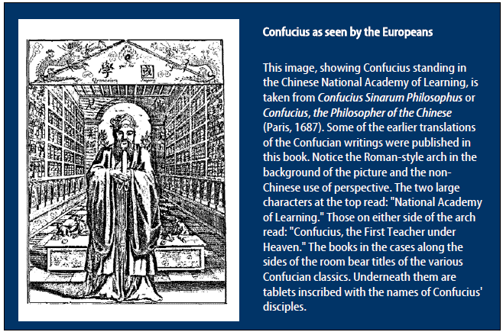
The most famous leader of the Enlightenment to fall under the Chinese spell was Voltaire (1694-1778), to whom Confucius was the greatest of all sages. A portrait of Confucius adorned the wall of his library. He regarded China as the one country in the world where the ruler is at the same time a philosopher (Plato's "philosopher-king"). He praised it because it had no priesthood owning 20 percent of the land, and contrasted the religious tolerance of the Chinese, who had never tried to send missionaries to Europe, with the European habit of always forcing their own religious ideas upon other people. "One need not be obsessed with the merits of the Chinese," he wrote in 1764, "to recognize . . . that their empire is in truth the best that the world has ever seen."

