Name _________________________________________ Period __________ Date ________________________
Directions: Read the passage below, underline/highlight and annotate the main ideas of each paragraph. Circle any words you do not know. Then answer the accompanying questions on the other side in COMPLETE SENTENCES. Use the map to assist you. Most of questions are based on your own opinion/thinking. Support your opinion with evidence from the reading and the map.
Collapse of France
During the winter of 1939-40, the French army and the German Wehrmacht (military) faced one another in what was regarded satirically as the sitzkrieg, or sit-down war. The world waited in anticipation of a major conflict between two powerful forces. On May 1940, a bridgehead was established at Sedan, considered the gateway to France, and then suddenly, on May 16, 1940, a day after the Dutch capitulation, the German blitzkrieg was released on northern France. German mechanized forces outflanked the Maginot Line, surprise the Allies by attacking through the wooded Ardennes rather than the Belgian plain, and drove the British Expeditionary Force (BEF) from the continent at Dunkirk. On June 5, the Germans launched another offensive southward from the Somme. They entered Paris unopposed on June 14 and forced France to sign an armistice at Compiegne on June 22, 1940.
The fall of France was an extraordinary victory for Hitler. The supposedly unbeatable French army had melted away before the onslaught of his mobile units with their convincing mechanized power. Nazi Germany then occupied most of France and permitted the establishment of a friendly government at Vichy, in central France on the Allier River.
The Vichy Government was headed by Marshal Henri Petain, a hero of World War I, and Pierre Laval, a collaborationist. Disgruntled French patriots rallied around General Charles De Gaulle, who pronounced himself leader of Free France, based in London.
During the early months of the war, Benito Mussolini maintained Italy’s neutrality. When France was about to fall, he decided to join the Nazis. Declaring war on the Allies on June 10, 1940, he invaded southern France in what U.S. president Franklin D. Roosevelt described as a “stab-in-the-back.”

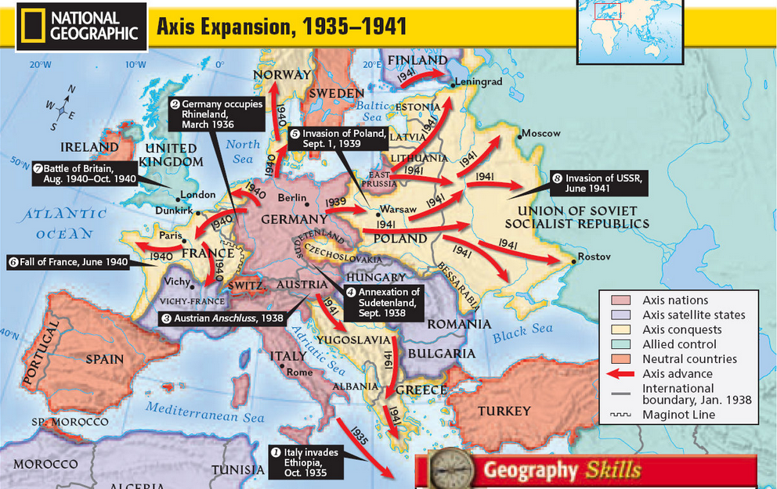
Colored version: http://goo.gl/dpSyy3
Questions:
- What gave the Germans the advantage over the French and Allied forces?

- Why do you suppose the Germans went around the Maginot Line instead of attacking it directly?

- Why do you think Franklin D. Roosevelt would describe Italy’s action in attacking France a “stab-in-the-back?”

- Based on the map on Axis expansion, what do you think would be a disadvantage to the Axis rapid expansion?

