Name ___________________________________ Date ________________________ Period ________

Directions: Fill in the blanks with relevant information/notes as the Totalitarianism Unit progresses.

10 Steps to  Dictatorship/Fascism | 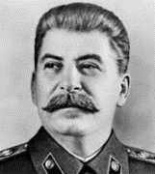  Soviet Union | 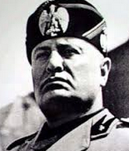  Italy | Germany
- Invoke external/internal threat
- Establish secret prisons/gulags
- Develop paramilitary force/thug caste
- Surveil ordinary citizens
- Arbitrarily detain/release citizens
- Infiltrate citizens’ groups
- Target key individuals
- Restrict the press/speech
- Cast criticism as “espionage” and dissent as “treason”
- Subvert/Undermine the rule of law

