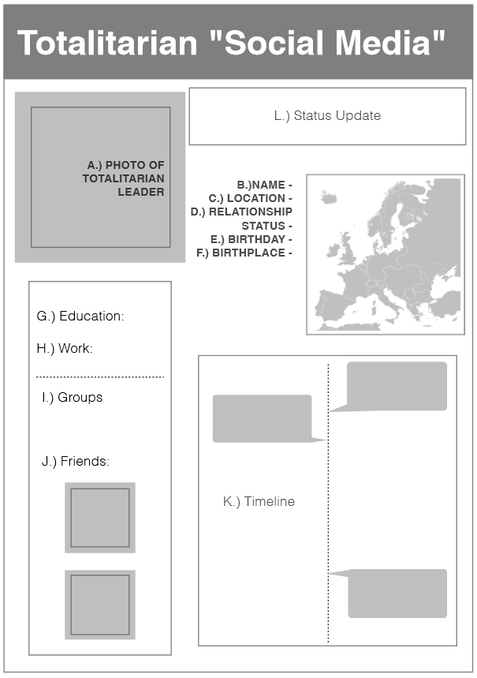

**Totalitarian Profile Page**

**Directions:**

Select one of the totalitarian leaders we cover in this unit (Lenin, Stalin, Hitler, and Mussolini, or another similar leader of choosing (must ask teacher for permission first)) and create a "social media profile page" poster for him. The layout to the left is just an example, feel free to design your poster any way you like, just make sure you include all the required information listed below.

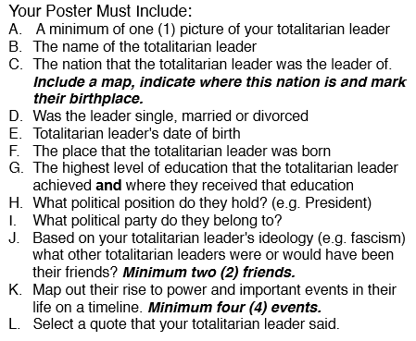

**Grading:**

A – F are worth one (1) point = _____/6

G-J & L are worth two (2) points = _____/8

K is worth four (4) points = _____/4